1.a)

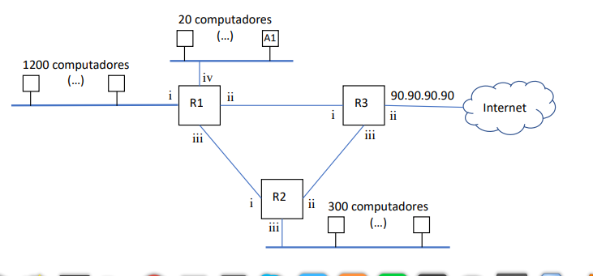

140.0.134.254/26

140.0.135.31/27

140.0.134.190/26

140.0.128.13/30

140.0.128.9/30

140.0.128.10/30

140.0.128.6/30

140.0.128.5/30

140.0.128.2/30

140.0.128.1/30

|  |  |  |  |  |
| --- | --- | --- | --- | --- |
| Hosts | End. rede | End. difusão | Mascara | End.Validos |
| 254(Rede1-i) | 140.0.129.0/24 | 140.0.129.255/24 | /24 | De 140.0.129.1/24 Até  140.0.129.254/24 |
| 254(Rede1-i) | 140.0.130.0/24 | 140.0.130.255/24 | /24 | De:140.0.130.1/24  Até:140.0.130.254/24 |
| 254(Rede1-i) | 140.0.131.0/24 | 140.0.131.255/24 | /24 | De:140.0.131.1/24  Até:140.0.131.254/24 |
| 254(Rede1-i) | 140.0.132.0/24 | 140.0.132.255/24 | /24 | De:140.0.132.1/24  Até:140.0.132.254/24 |
| 254(Rede2) | 140.0.133.0/24 | 140.0.133.255/24 | /24 | De:140.0.133.1/24  Até:140.0.133.254/24 |
| 126(Rede1-i) | 140.0.134.0/25 | 140.0.134.127/25 | /25 | De:140.0.134.1/25  Até:140.0.134.254/25 |
| 62(Rede1-i) | 140.0.134.128/26 | 140.140.0.128.9/30  140.0.128.10/30  0.134.191/26 | /26 | De:140.0.134.129/26  Até:14140.0.128.6/30  0.0.134.190/26 |
| 62(Rede2) | 140.0.134.192/26 | 140.0.134.255/26 | /26 | De:140.0.134.193/26  Até:140.0.134.254/26 |
| 30(Rede1-iv) | 140.0.135.0/27 | 140.0.135.32/27 | /27 | De:140.0.135.1/27  Até:140.0.135.31/27 |

b) Construa a tabela de encaminhamento para cada um dos routers. Para cada rota, indique a rede de destino, a interface de saída, o próximo nó e a métrica utilizada

R1

|  |  |  |  |
| --- | --- | --- | --- |
| rede de destino | interface de saída | próximo nó | métrica utilizada |
| 140.0.133.0/24 | 140.0.128.10/30 | 140.0.128.9/30 | 1 |
| 140.0.134.192/26 | 140.0.128.10/30 | 140.0.128.9/30 | 1 |
| 90.90.90.90 | **140.0.128.13/30** | 140.0.128.1/30 | 1 |

R2

|  |  |  |  |
| --- | --- | --- | --- |
| rede de destino | interface de saída | próximo nó | métrica utilizada |
| 140.0.129.0/24 | **140.0.128.9/30** | **140.0.128.10/30** | 1 |
| 140.0.130.0/24 | **140.0.128.9/30** | **140.0.128.10/30** | 1 |
| 140.0.131.0/24 | **140.0.128.9/30** | **140.0.128.10/30** | 1 |
| 140.0.132.0/24 | **140.0.128.9/30** | **140.0.128.10/30** | 1 |
| 140.0.134.0/25 | **140.0.128.9/30** | **140.0.128.10/30** | 1 |
| 140.0.134.128/26 | **140.0.128.9/30** | **140.0.128.10/30** | 1 |
| 90.90.90.90 | **140.0.128.6/30** | 140.0.128.5/30 | 1 |

R3

|  |  |  |  |
| --- | --- | --- | --- |
| rede de destino | interface de saída | próximo nó | métrica utilizada |
| 140.0.129.0/24 | **140.0.128.1/30** | **140.0.128.13/30** | 1 |
| 140.0.130.0/24 | **140.0.128.1/30** | **140.0.128.13/30** | 1 |
| 140.0.131.0/24 | **140.0.128.1/30** | **140.0.128.13/30** | 1 |
| 140.0.132.0/24 | **140.0.128.1/30** | **140.0.128.13/30** | 1 |
| 140.0.134.0/25 | **140.0.128.1/30** | **140.0.128.13/30** | 1 |
| 140.0.134.128/26 | **140.0.128.1/30** | **140.0.128.13/30** | 1 |
| 140.0.135.0/27 | **140.0.128.1/30** | **140.0.128.13/30** | 1 |